## What is in a sign?

We won’t bother going into too much detail about the composition of a sign here - that’s what the next chapter is for. However, it does help to know a little bit about how the signs are built as it will give you an understanding of what they can do.

Each sign in RapidPlan has its own sign file saved on your computer, and almost every sign file contains multiple variations of the same sign. A typical sign has four variations.

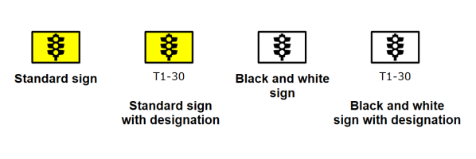

Sign_Variations

The reason behind the multiple variations lies in the features of the RapidPlan canvas:

* When Fax Mode is selected, the signs need to be able to be displayed in black and white.
* When Sign Designations are turned on, the software needs to be able to display a variation of each sign with its code.